A Life That’s Good by Sarah Siskind and Ashley Monroe

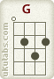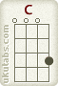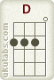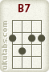

G
Sitting here tonight, by the firelight,
C G
it reminds me I already have more than I should.
G
I don’t need fame, no one to know my name.
C Am7
At the end of the day, Lord I pray
D G
I have a life that’s good.

C D
Two arms around me, Heaven to ground me,
G C
and a family that always calls me home.
C D
Four wheels to get there, enough love to share
B7 Em
and a sweet, sweet, sweet song.
C Am7
At the end of the day, Lord I pray
D G
I have a life that’s good.

G
Sometimes I'm hard on me, when dreams don't come easy
C G
I wanna look back and say I did all that I could.

C Am7
At the end of the day, Lord I pray
D G
I have a life that’s good.
C D
Two arms around me, Heaven to ground me,
G C
and a family that always calls me home.
C D
Four wheels to get there, enough love to share
B7 Em
and a sweet, sweet, sweet song.
C Am7
At the end of the day, Lord I pray
D G
I have a life that’s good.

C Am7
At the end of the day, Lord I pray
D G
I have a life that’s good.

