LITTLEST BIRDS by the Be Good Tanyas
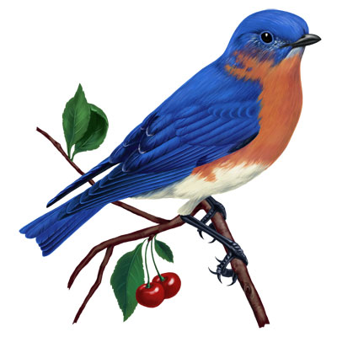

F C G (C F C G repeat x2)

C F C G
Well I love you so dearly I love you so clearly
C F C G
I wake you up in the mornin' so early,
C F C G
Just to tell you I got the wanderin' blues.
C F C G
I got the wanderin' blues,
C F C G C F C G C F C
And I'm gonna quit these ramblin' ways one of these days soon,
G C
And I'll sing :
F C G C
The littlest birds sing the prettiest songs.
F C G C
The littlest birds sing the prettiest songs.
F C G C
The littlest birds sing the prettiest songs.
F C G C
The littlest birds sing the prettiest songs.

F C G (C F C G repeat x2)

C F C G C
Well it's times like these I feel so small and wild
F C G G C
Like the ramblin' footsteps of a wanderin' child.
F C G C
And i'm lonesome as a lonesome whippoorwill,
F C G C
Singin these blues with a warble and a trill.
F C G C
But i'm not too blue to fly,
F C G C
No i'm not too blue to fly 'cause
F C G C
The littlest birds sing the prettiest songs.
F C G C
The littlest birds sing the prettiest songs.
F C G C
The littlest birds sing the prettiest songs.
F C G C
The littlest birds sing the prettiest songs.

F C G (C F C G repeat x2)

…Littlest Birds

C F C G
Well I love you so dearly I love you so fearlessly,
C F C G
I wake you up in the mornin' so early,
C F C G
Just to tell you I got the wanderin' blues.
C F C G
I got the wanderin' blues,
C F C G C F C G
And I don't wanna leave you I love you through and through.
C F C G
Oh I left my baby on a pretty blue train,
C F C G
And I sang my songs to the cold and the rain.
C F C G
But I had the wanderin' blues,
C F C G
And I sang those wanderin' blues.
C F C G C F C G C F C
And i'm gonna quit these ramblin' ways one of these days soon,
G C
And i'll sing :
F C G C
The littlest birds sing the prettiest songs.
F C G C
The littlest birds sing the prettiest songs.
F C G C
The littlest birds sing the prettiest songs.
F C G C
The littlest birds sing the prettiest songs.

F C G (C F C G repeat x2) C

