- Moonlight Lady
Download Moonlight Lady 320kbps mp3
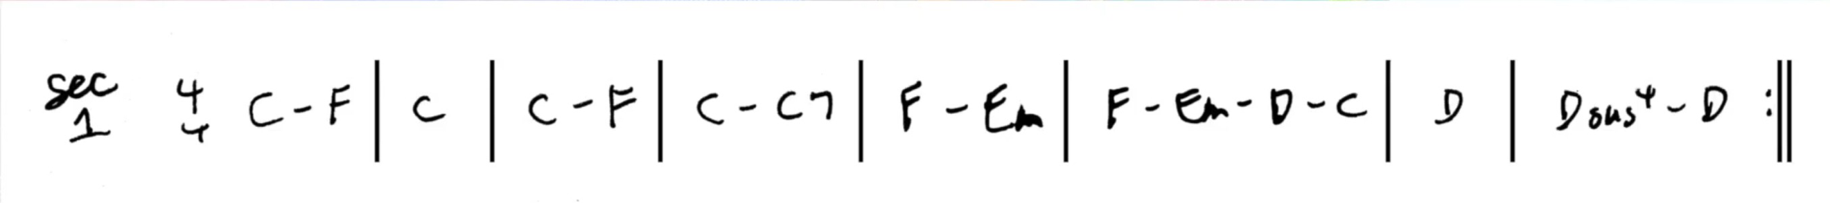
Moonlight Lady, eyes dark as the midnight sky

Not too many friends forget your smile

Moonlight Lady, arms strong as the valley walls

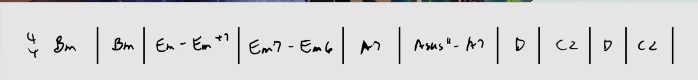
Not too many friends forget your touch.

You work in the fields by day

In the sun while your children play

River sings their lullabies

and rainbows fill their youthful eyes.
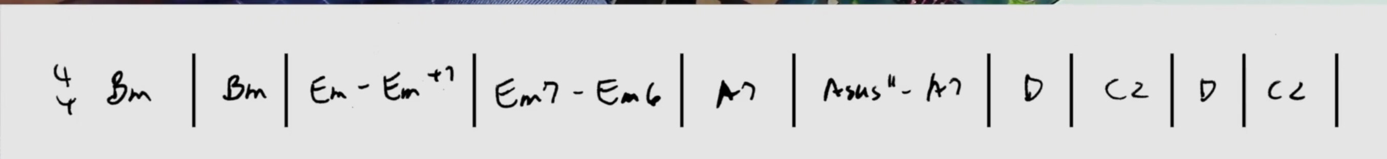
You work in the fields by day
In the sun while your children play
River sings all their lullabies
and rainbows fill all their youthful eyes.

Moonlight Lady, voice like a running stream
Not too many men forget your song
Moonlight Lady, skin warm as the noonday sun
Not too many men forget your stove (I can't quite make out the last word...stow, snow, stove, ??)


I[

